LRA Board Meeting: July 16, 2022
Present: Bruce Zanca, George Thomson, Phil Newell, Spencer Rubin (Zoom), Barb Silver (Zoom), Gigi Katsiff (Zoom)
Bruce convened the meeting at ???
Treasurer’s Report
- Bruce presented the financial report in Kevin’s absence.
- Picnic…. Cost/Benefit discussion and possible improvement for next year
- Excellent enthusiasm by all attendees. Ice cream truck could stay longer next time.
- All board members engaged with members.
- PA system could be wireless
- The food was very good
- Go to Financial statements
Phil moved to approve financial report. Approved
Minutes of June 18 Board meeting:
- Barb moved to approve as submitted; Bruce seconded. Approved
- Go to June 18 meeting minutes

Milfoil:

- Bruce has been on the Dash boat. There have been some mechanical issues.
- Engine repair had to be made in Castleton. Under warranty.
- There is a motor on the DASH boat with 2 functions: one to run the suction, and the second to provide air for the diver. One seal failed and had to be replaced. Cat had a spare seal on hand, and it was fixed by Bruce and the divers.
- Some of the bottom barriers were ‘wrinkled’ because of strong wind last week. Cat was able to smooth them out and redeploy them.
- This year the milfoil seems a bit better.
- George reports many plants coming over the spillway, just beyond the concrete. He had several volunteers scooping fragments.
- Phil reviewed volunteer coverage around the lake. Good coverage on Round Pond. Far fewer plants than prior years.
- There is no coverage in the NE cove of the big lake. There are mats down in this area, but still a lot of plants
- Zone 2 : 4 people; zone 3 no-one; But zone 3 is deep.
- Zone 10, maybe A. Zinkerman, Zone 9, 8?
- Spencer can join with Liz S. in Zone 8

Sedimentation:
- Kevin , Bruce and Natalie met with Plymouth officials and Farm & Wilderness regarding Patch Brook Rd.
- Plymouth doesn’t have resources to make repairs. They have priorities they have to fulfill with the state.
- J Eckel set up a call with Richard Regiulio (?) from Lake Amherst and Bruce, looking for our support. He wanted to make a presentation at this meeting and at our Annual Meeting.
- There was a lot of hesitancy to have this issue brought up at our Annual Meeting
- State will pay to remove the Amherst dam but not to repair the dam.

Lake Safety
- Possible addition of a No Wake Buoy in Gigi’s cove, due to fast boats.
- Game warden will come to speak at our annual meeting
- John Widness has been in touch re Regulation of Wake Boards. Our concern is the safety threat of these boats and possible swamping of kayaks.
- We have 4 No Wake buoys: Slacks Pasture, Archibald cove, and N & S of channel.
- Phil moved to buy up to 2 more buoys. One for the NE cove of lake, and one in the NW cove of lake. George seconded, Passed.

Membership, Outreach, Neon
- 86 full members signed up online since Membership call went out. Mail-ins not included.
- Barb will send out reminder this week.
- Kathy Burns has offered post cards to send out to members.
- This is Barb’s last meeting, and Bruce thanked Barb for her many contributions to the LRA and the lakes.

Annual Meeting
- We will all supply slides for the presentation.
- Invited to speak/ answer questions: Town Manager, Game Warden, Bruce Schmidt
- Possible Amherst Dam item
- Cat and Shane will not speak this year, because George and Phil can handle that topic.
- Okemo Valley TV will film the meeting. Last year it cost $150.
- Community Center is now charging us $65 to use their space.
- Promote TV recording to new members.
- Publicize the customs on our lake, eg., Counterclockwise boating.
- Barb will send template for powerpoint slides
- George will bring coffee & refreshments, Donut holes.

Board Nominations
- No nominations for remaining open board seat.
State Dock
- Next status conference is scheduled for Aug 1; we are seeking postponement to find a new lawyer.

Spencer moved to adjourn; Phil seconded. Adjourned at ???

Addenda:

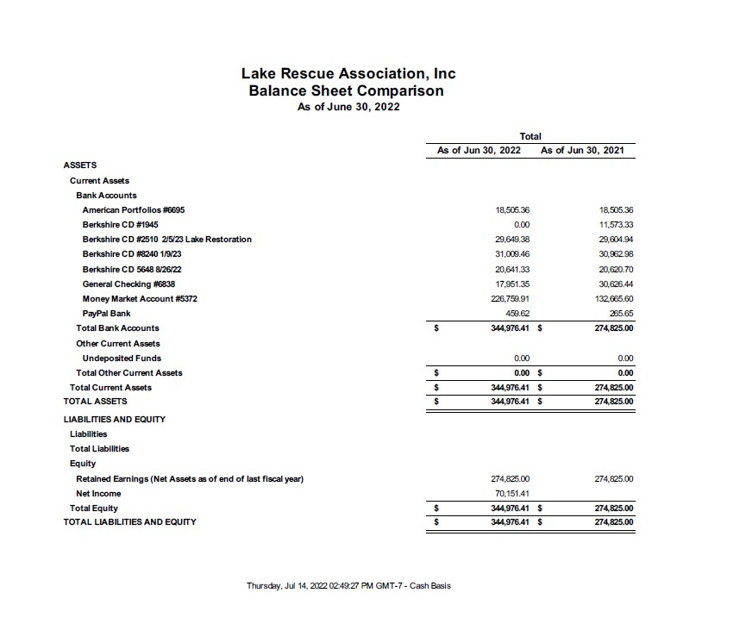
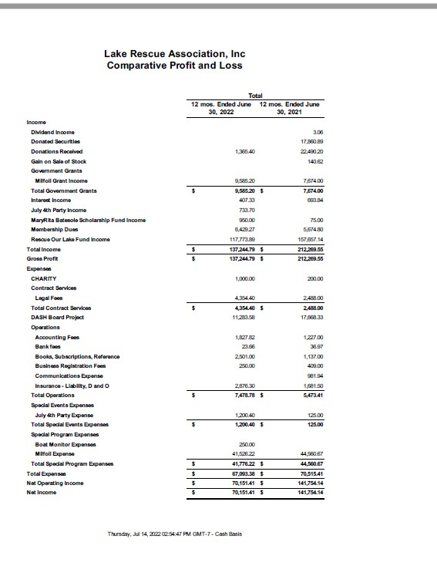

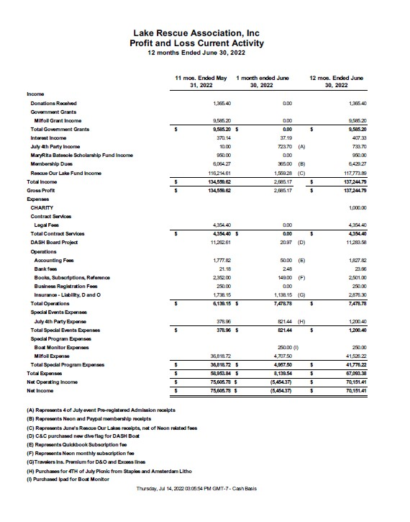
--------------------------------------------------------------------------

June 18, 2022, Meeting minutes

